REFERENCE SHEET

Movement/Keyboard Control
- End key cycles through camera views
- PgUp/PgDn lets you look up/down
- +/- allows you to fly/descend
- Shift allows you to walk through things
- Ctrl allows you to run
- The back/forth triangle buttons on the top of the browser can be used to jump quickly between worlds
- The teleport tab on the left menu is also a good way to get between locations
Creating Objects
- Rt. Click on a object to open the object properties box
- Use insert key to create a new copy
- Move it away from the original object using…
  - arrow keys move it back and forth across the same plane
  - +/- move it up and down
  - Rotation: PgUp/PgDn rotate it around the Y-axis (each press of the button is 15 degrees)
  - Tilt: Home/End rotate it around the X-axis (15 degrees)
  - Shift + movement key will move it 1.5 degrees instead of 15, for more accurate placing (only necessary with smaller objects)
  - delete will delete it
- Modify Model/Description/Action as needed
  - Model specifies the object—these can be found in the object directory
  - Description: this is where you put sign text, or a description of the object
  - Action allows you to give objects special properties
    - Triggers: tell a command when to execute—i.e. create (execute upon creation), activate (execute when object is clicked)
      - Semicolons should be used between multiple triggers.
    - Commands: move, picture, sign, teleport, texture, etc.
      - Commas should be used between commands
    - Example: If in the action box you’ve written ‘create sign, rotate 10; activate visible no’ you will create a rotating sign that turns invisible when you click on it.
      - Note the semicolon between triggers and the comma between commands
      - You can view examples by right clicking on any object
  - Arguments can be added after a command—these change certain properties of the object such as naming it or making it invisible
- Find model codes by right clicking on objects you see, or get them from the object yard (you can use the teleport tab in Tab controls to get to the object yard quickly)
- You can select multiple objects at once by holding down the shift key as you right click on objects. Now they will all move together and rotate around a common center point

Signs
- Create an object using the insert key
- The text you’d like on the sign goes in the description box
- In the action box, syntax is as follows: create sign color=color bcolor=color
- There are several types of signs you can choose from. Here are a few and their models. Just type the object names in the model box
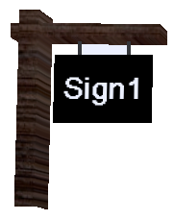 | 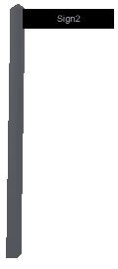 | 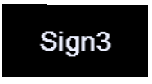
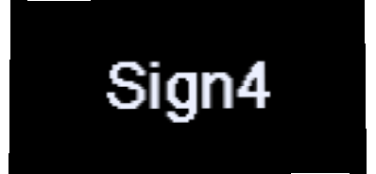 | 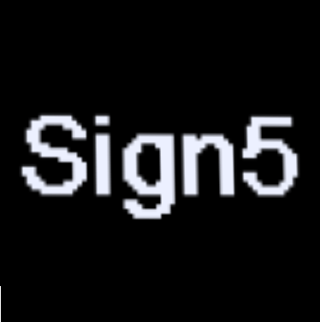 | 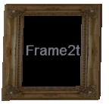

Pictures
- You can pull pictures off the web to display. They must be in .jpg format
- The syntax, to go into the action box, is: create picture url
- There are several types of picture frames... Here are a few and their models. Just type the object names in the model box.
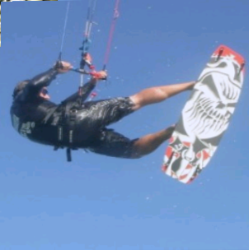 | 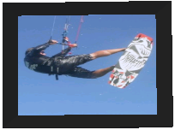 | 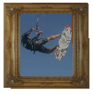 | 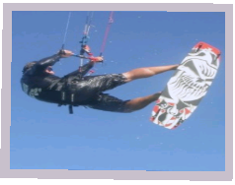
Pictwll2 | Tv2bs | Frame2p | Pict1

- It is important to keep track of your sources! All material taken from the web should be cited. A sign with text that lists where you found your pictures/material will do. For information on citing, visit http://www.library.cornell.edu/t/help/res_strategy/citing/apa.html
Color
- Create color color
- Done either with preset words (blue, green) or with ‘raw’ hexadecimal values
- Bump color color makes the object change color when you bump into it
- Name argument can be used, but not tags or masks
Visible
- Objects, when invisible, can still be bumped and so can be used to trigger something else.
- Syntax: Visible on/no
- Best used—name an object, and then have another one activate it.. i.e. create name name, visible no (= invisible object), and then another one that has the command activate visible name on
- Bump panels can be created but will only work from one direction unless they are not solid (create solid no)
Solid
- Makes an object solid or unsolid—only use when you want it unsolid
- Syntax: ‘create solid no’ or ‘activate solid no’
- To make something unsolid, name it, then give the trigger the syntax ‘activate solid name no’
Coronas
- Places a transparent image stamped on to the 3D scene on top of an object whenever that object is visible to the user—creates a halo effect around local light sources
- ‘create corona texturename’ followed by…
  - Texturename: specifies the name of the texture to be used as the corona—must be on the world’s object path. Some textures have been specifically designed to be coronas: flare2, flare3, c_flare1, etc
  - Mask: create corona texturename mask=maskname→specifies a texture mask for masking the corona texture. If none specified, corona will be self-masking(transparency mask for the texture is generated from a grayscale version of the same texture
  - Size: create corona texturename size=size→ controls size of corona, default=100 (but that’s large)
  - Name: create corona texturename name=name→ name the object, then make a switch that will turn the light/corona on and off
  - Argument
- To make a corona emit from somewhere other than the center of an object, create a small object, give it a corona, and make it invisible. Position it where you want the corona: create corona c_star2 size=20,visible no
Media
- Allows you to play audio and video files, but only works on sign objects, so everything should go in the action field
- Syntax: (create/bump/activate) media url=url ["Info text"] [name=name] [set OR pause OR stop] [color=color] [bcolor=bcolor] [res=#] [fx=3D] [radius=#] [radoff=#] [vol=#] [loop=#] [osd=on/off] [ext=on/off] [nostop]
- Arguments
  - url: specifies web-address of media file. If this is empty and a name is specified, it will stop running media on all objects with that name.
  - Info text: will be displayed while media is loading and after it has finished. Must be in double quotes. If not there, will show description text
  - Set: changes the attributes (volume, radius) of a media on the fly: vol=50
  - Pause: pauses media when you click something else, then unpause
  - Stop: click something to stop it (default is you click the sign and it stops)
  - Color/bcolor only matter for the sign
  - Res can be 64, 128, 256, &512. default is 256
  - Fx: specifies a sound effect applied to the media.
    - 3D: causes the sound to pan according to your avatar’s position
    - Radius: the maximum distance in meters the sound can be her (default = 30)
    - Vol: relative volume of sound
    - Radoff: max distance at which media will play. Default=30m
  - Loop: default is one, but specify a # of times
  - Osd: specifies if TV-like on-screen display should be displayed on top of the video frames
  - Ext: should video be on sign, or in a pop-up
  - Nostop disables the mouse click of bump trigger to stop running media
Moving Objects:
- Syntax: move x y z [loop OR noloop] [sync OR nosync] [reset OR noreset] [time=time] [wait=wait] [name=name]
- X Y and Z must always been specific—they are the distance and directions where the object will move to. A minus before the number will reverse the direction
- Noloop is default, loop make the motion continue
- Sync and nosync specify whether or not a looped mover is synchronized to the universe clock, so all users see it moving at the same time
- Reset specifies whether or not the object returns to its starting point.
- Time is how long it will take to move from start to finish—default is 1 second
- Wait specifies how long a looping mover waits at either end of its journey—default is zero
- Create move will make the object move automatically. You can also use activate, bump, etc.

